1.Create a P-T-S VPN and attach it to a VM.

For the creation of the P-T-S VPN we have to generate a certificate having client and root.

By using PowerShell ISE as a administrator Client and root install on a desktop.

After that in the settings vpn connected to a vm.

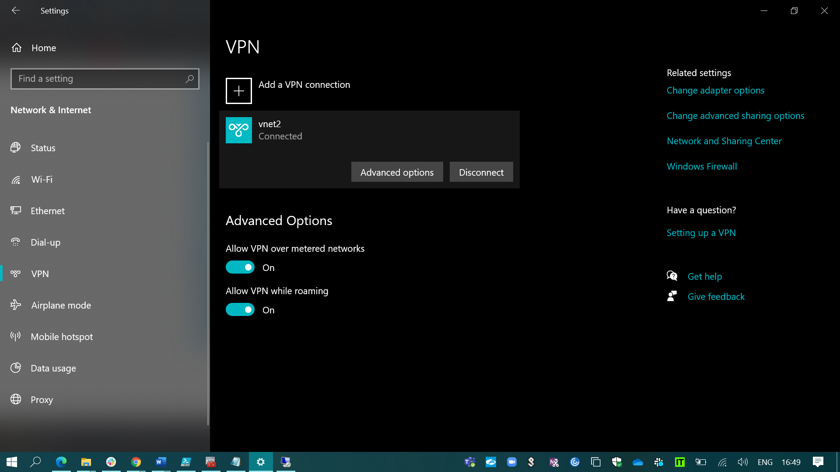

2.Create a two web application in west us and east us then attach to the traffic manager

With priority routing method.

At first we have to open app services there I have created two webApplications with the above two different locations.

Then I have created a traffic manager profile with priority routing method.

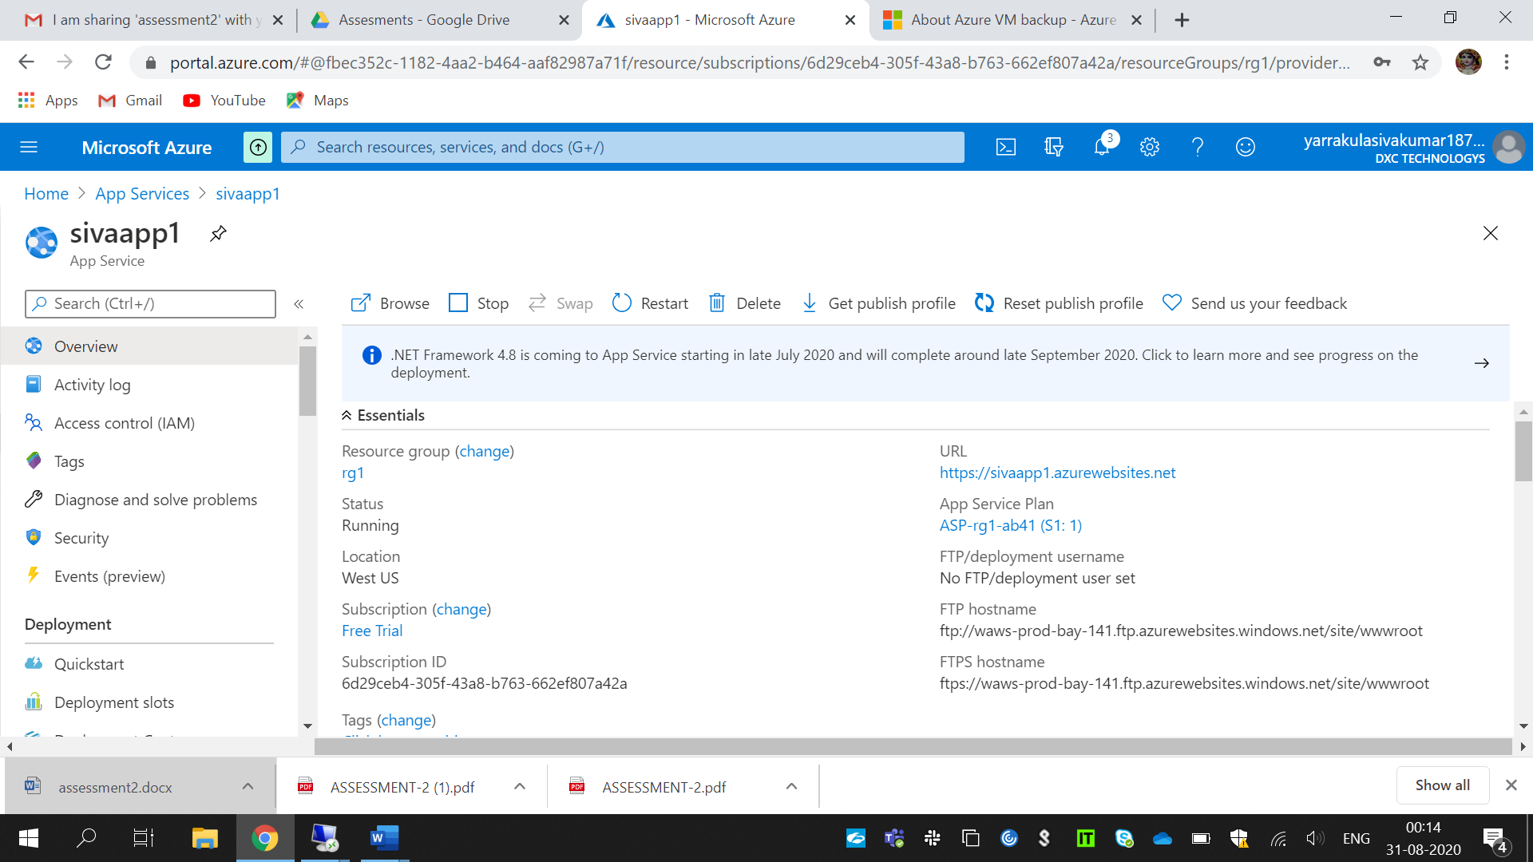

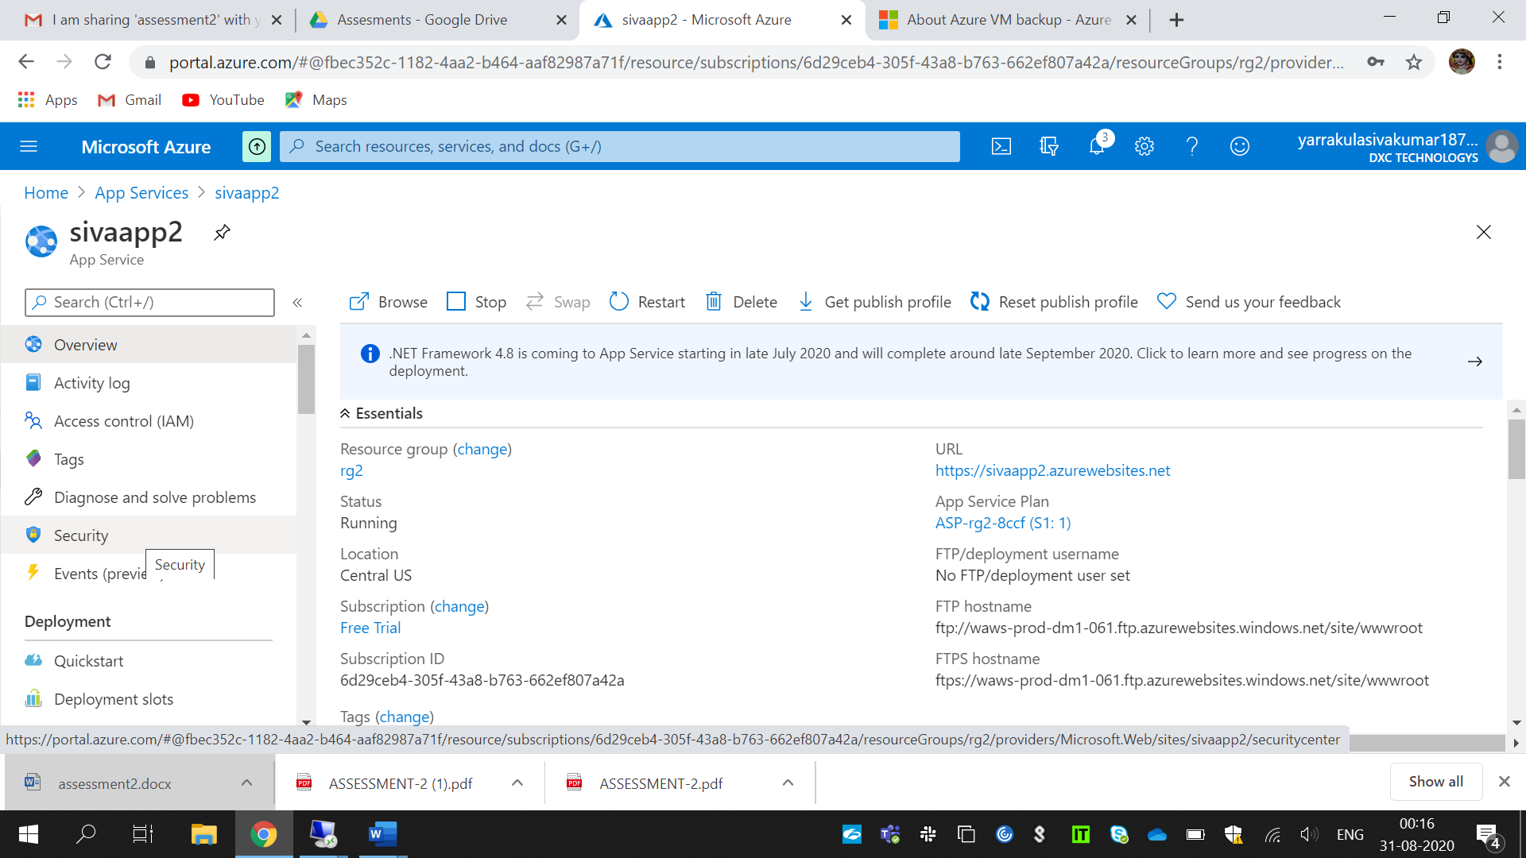Traffic manager with priority routing attached.

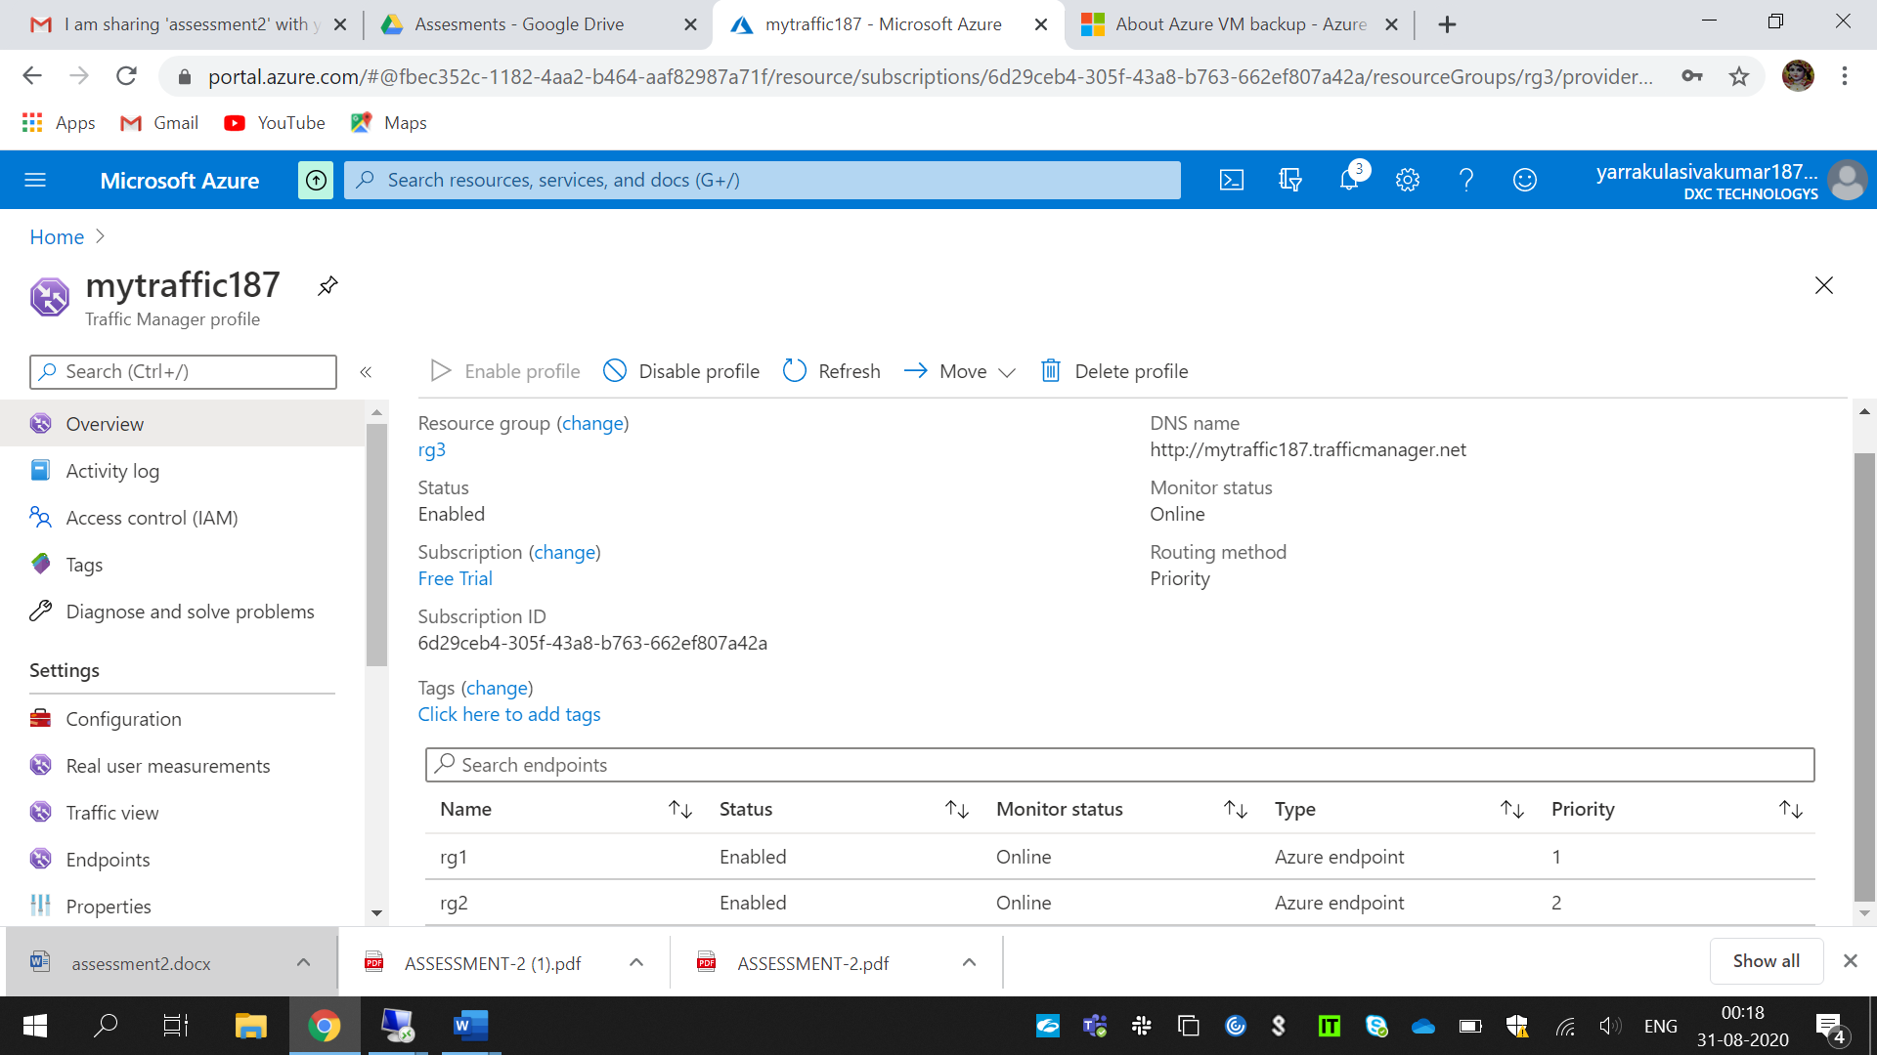

3.Created a windows server AD installed and integrate with azure AD.

For this I have to create a azure active directory and integrated my active directory

To azure AD.

Run desk top connection,add role and features then step by step followed to install a

Azure active directory. Also check the users.

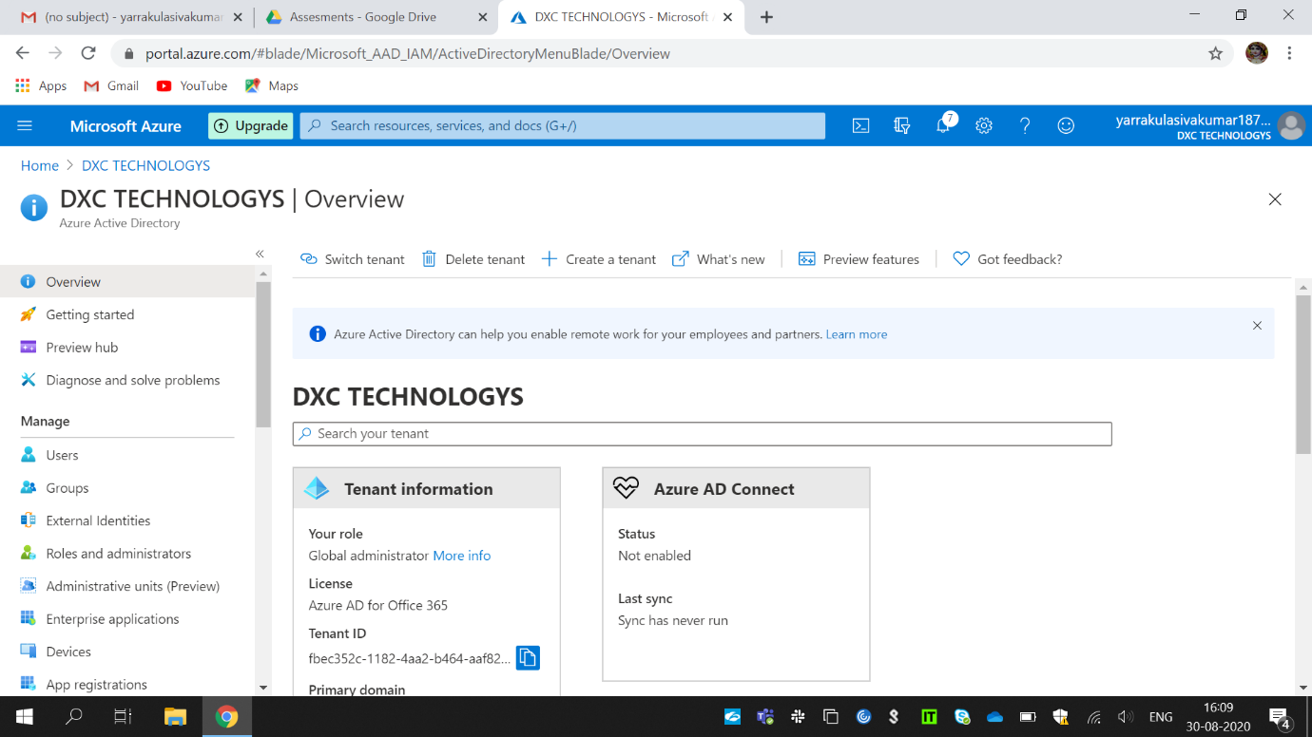

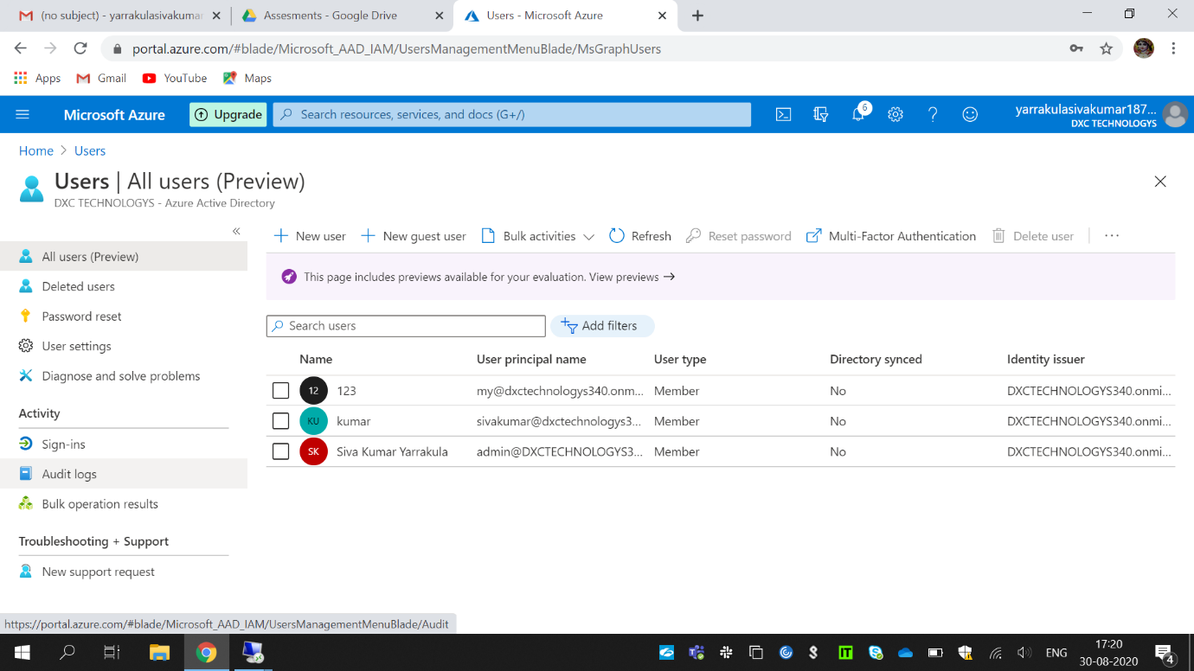

4.Configure a backup to the VM you installed AD.

In this first I had created a vm and backup that vm backup policy which already

Installed AD.

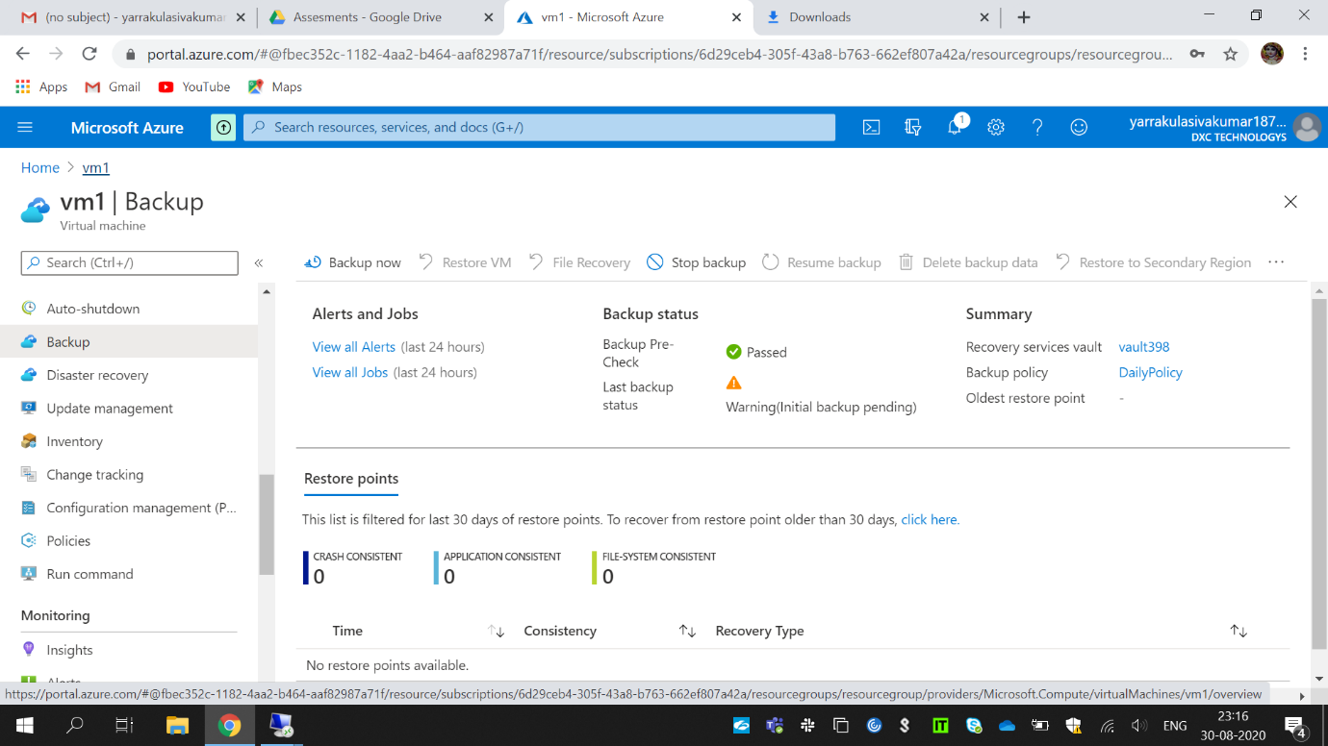

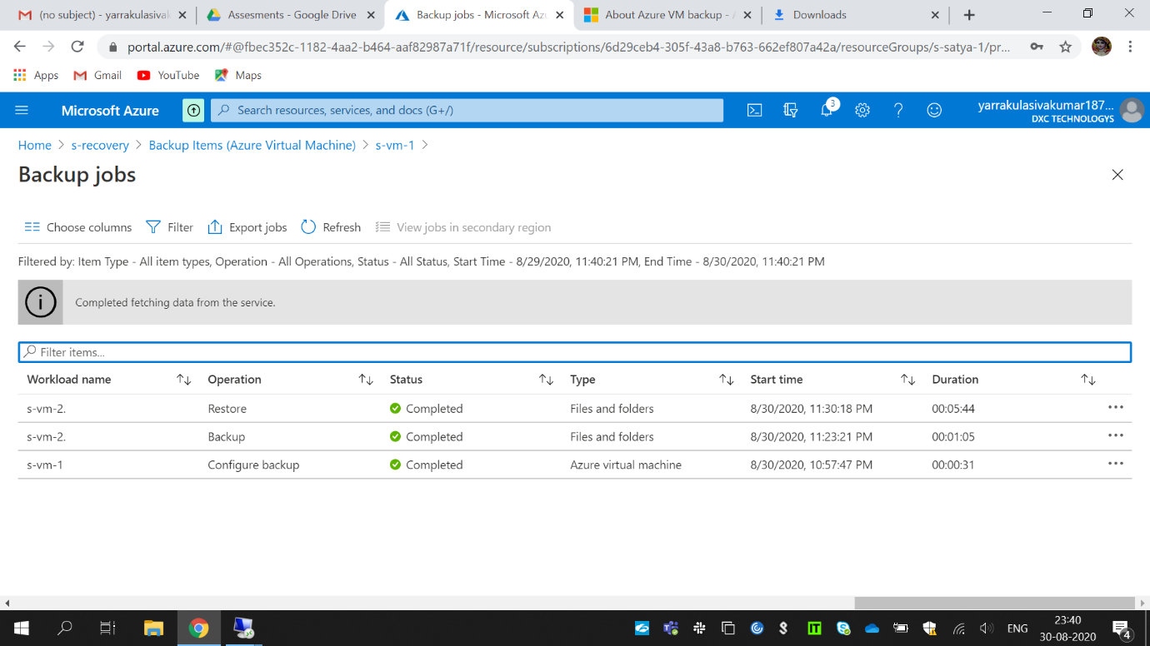

5. Configure alerts for the VM.

For this I had created vm and created alerts then configured the given alerts.

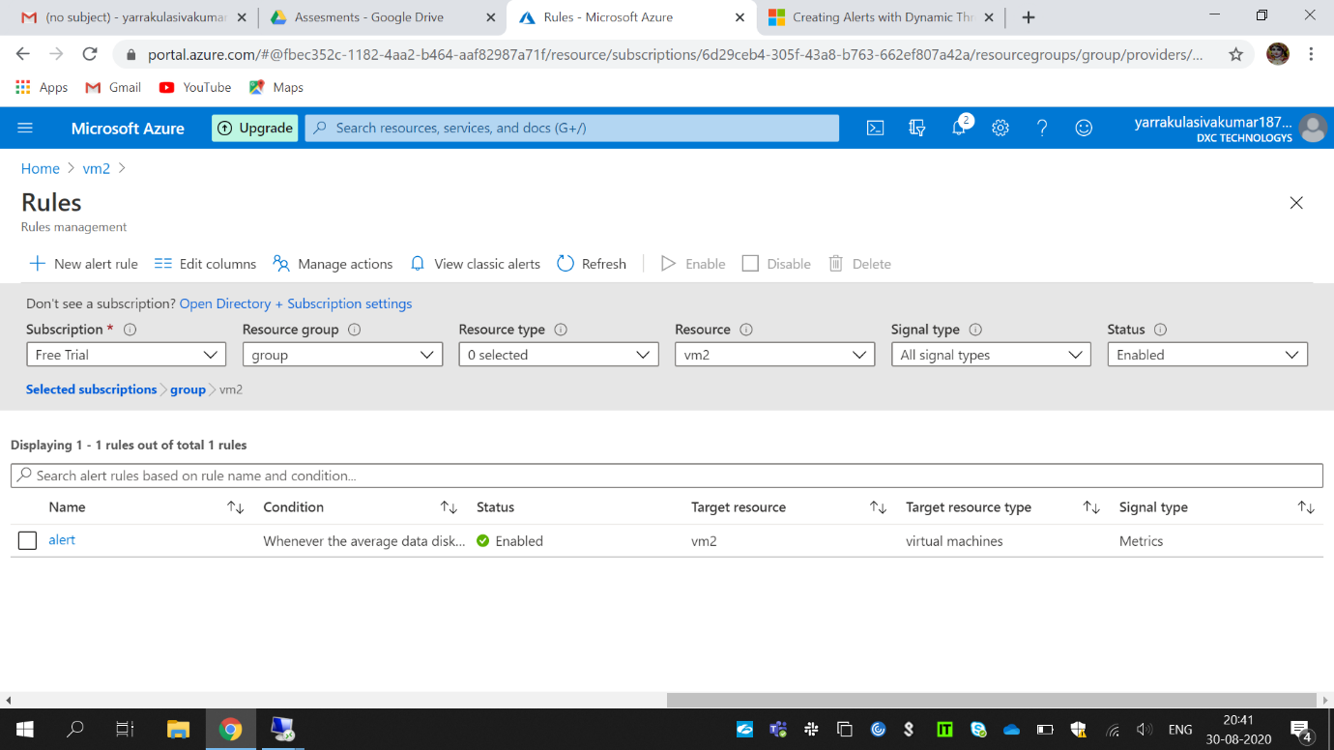

For the above alert ihave selected a signal logic and action group created and assigned.

6. Apply any security policy to the subscription.

Open a subscription after that select security center and in that add custom initiatives.

Select a vm apply security policy for that create and assign.

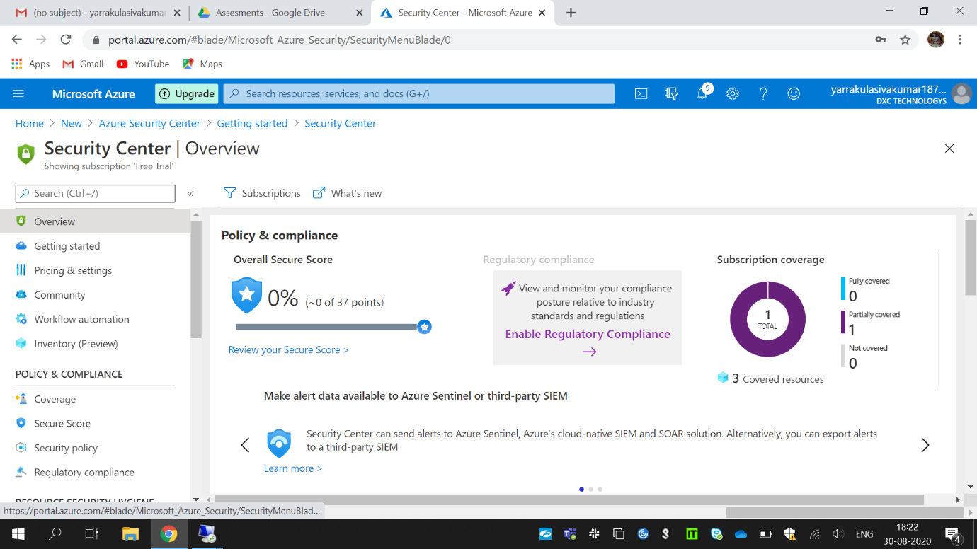

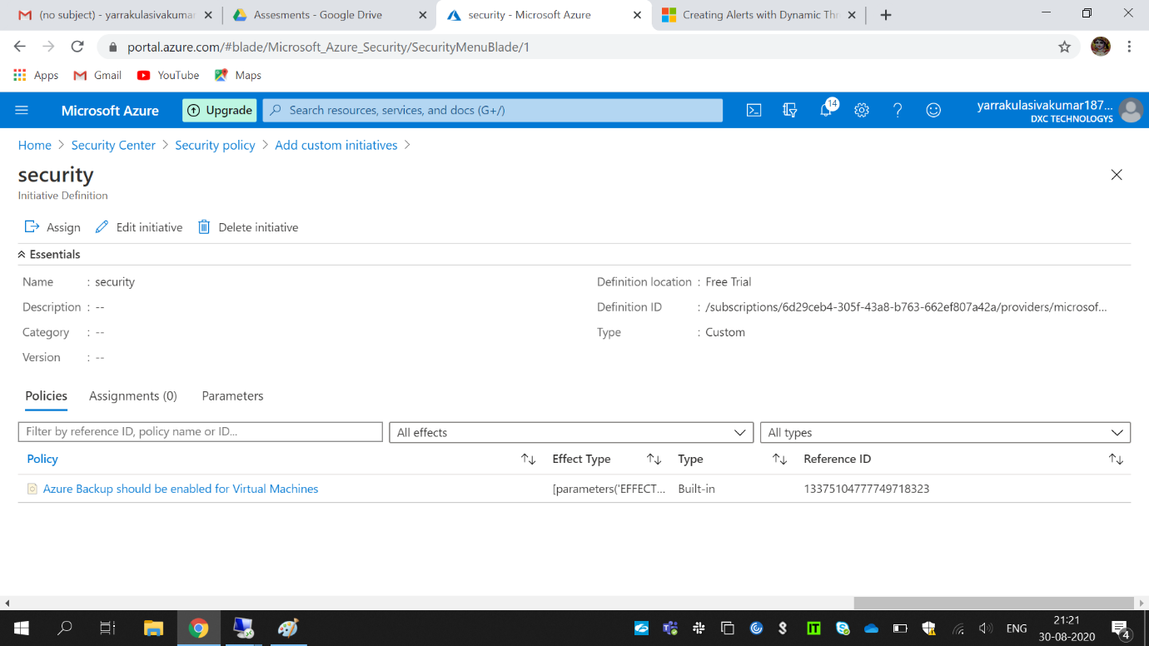

7.Create a SQL server with database installed in the elastic pool.

For this first create a SQL server, after that create a database installed .

By selecting elastic pool only can be performed .At last created the

Above given condition completed.

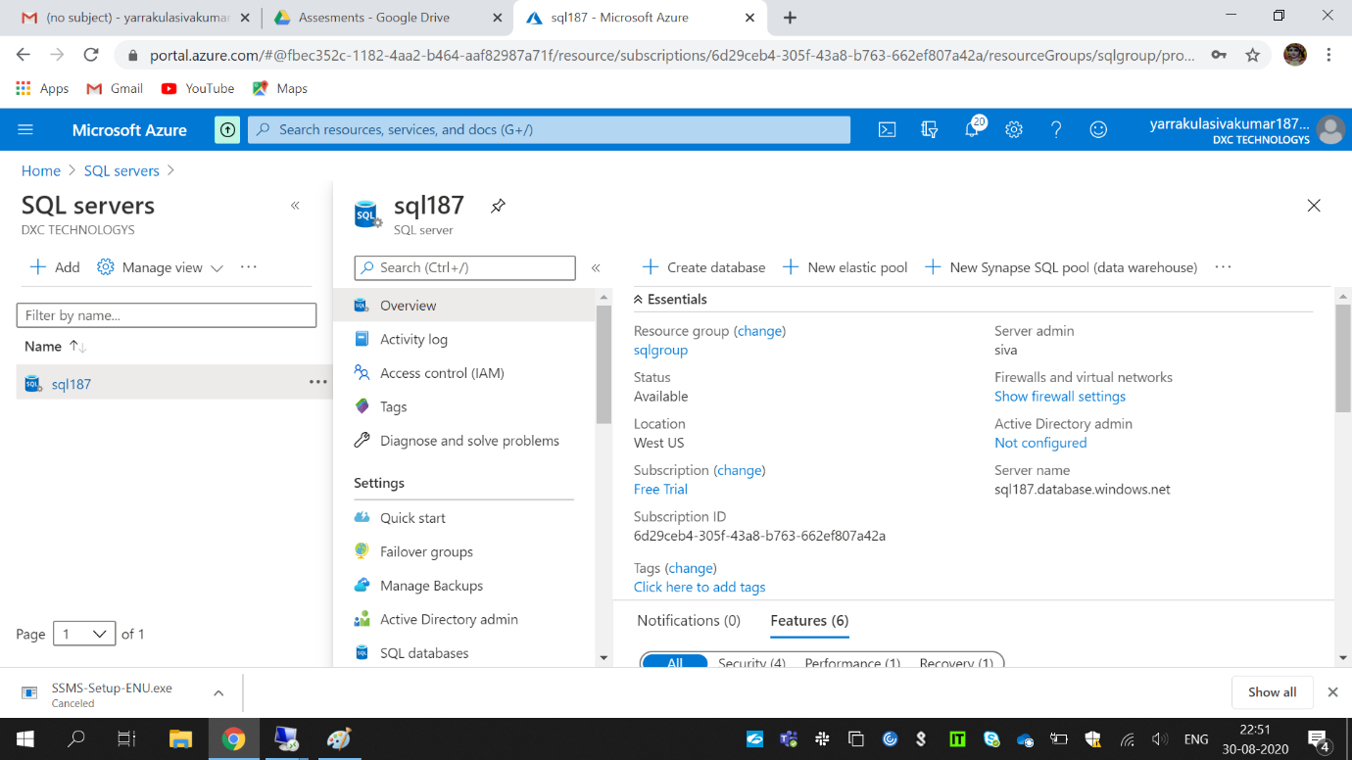

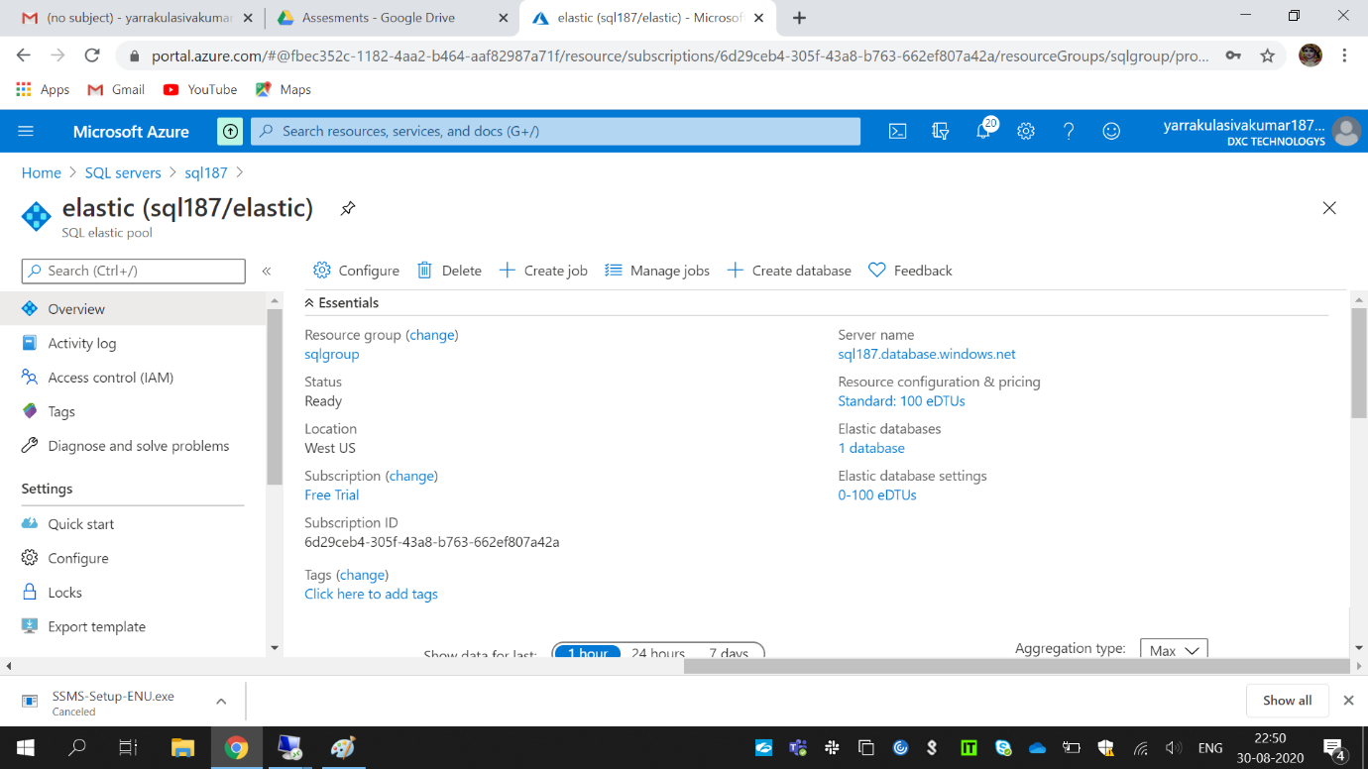

Database that I created using elastic pool.